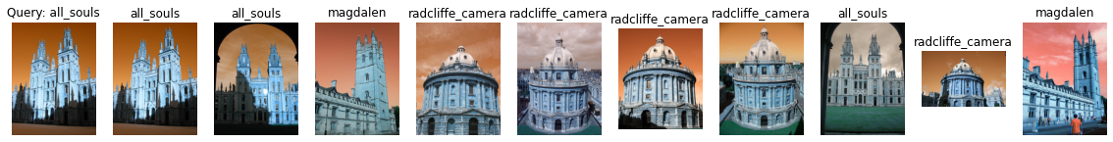

Label: all_souls

Average Precision for query 0: 0.3137988987057871

Precision@k for query 0: 0.3

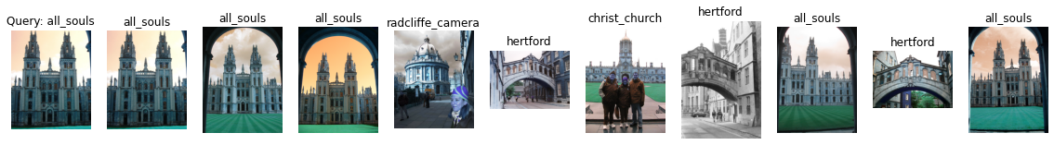

Label: all_souls

Average Precision for query 1: 0.26896978278981615

Precision@k for query 1: 0.5

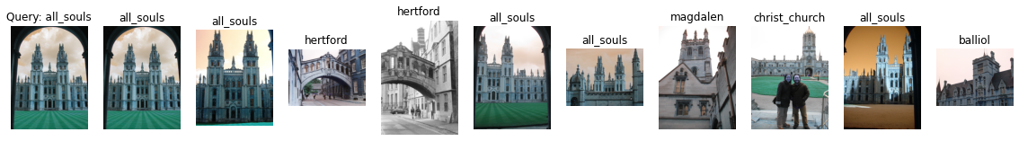

Label: all_souls

Average Precision for query 2: 0.2931301160464315

Precision@k for query 2: 0.5



Label: all_souls

Average Precision for query 3: 0.5947159088112508

Precision@k for query 3: 0.9

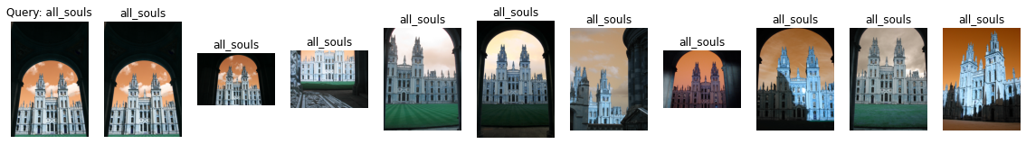

Label: all_souls

Average Precision for query 4: 0.48274645222910123

Precision@k for query 4: 1.0

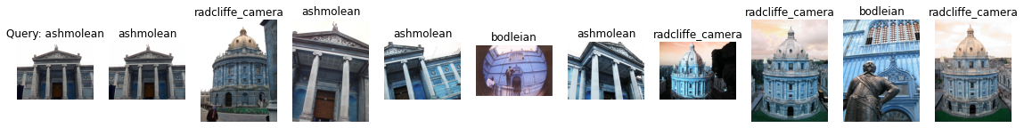

Label: ashmolean

Average Precision for query 5: 0.20944481888615837

Precision@k for query 5: 0.4

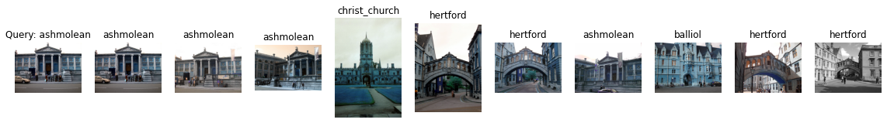

Label: ashmolean

Average Precision for query 6: 0.1970264976616862

Precision@k for query 6: 0.4

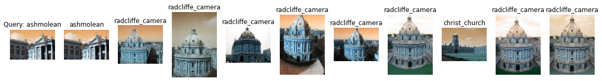

Label: ashmolean

Average Precision for query 7: 0.06951731073506076

Precision@k for query 7: 0.1

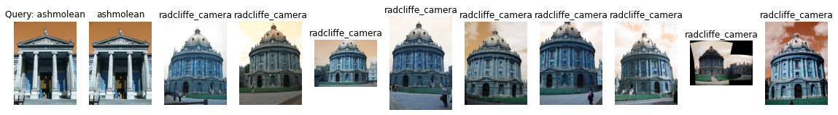

Label: ashmolean

Average Precision for query 8: 0.08934889992558132

Precision@k for query 8: 0.1

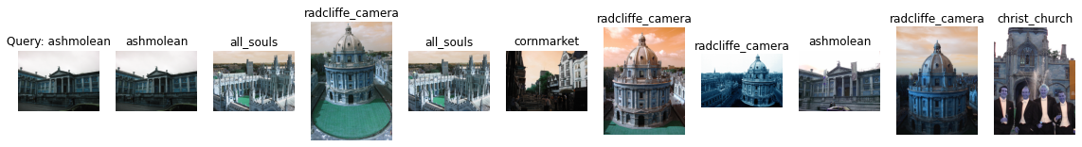

Label: ashmolean

Average Precision for query 9: 0.12777297880927688

Precision@k for query 9: 0.2

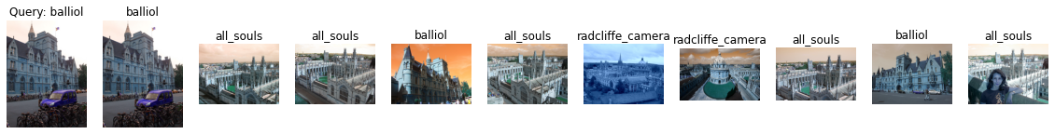

Label: balliol

Average Precision for query 10: 0.22444822968392356

Precision@k for query 10: 0.3

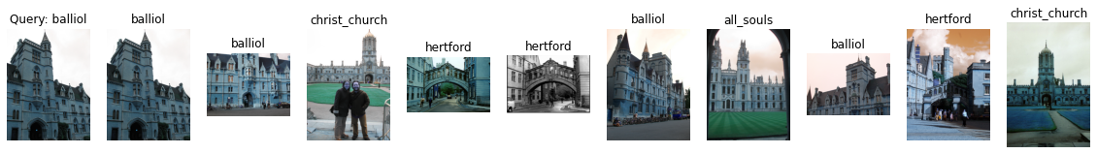

Label: balliol

Average Precision for query 11: 0.35213724480672476

Precision@k for query 11: 0.4

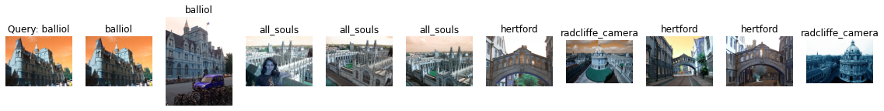

Label: balliol

Average Precision for query 12: 0.24288842582804882

Precision@k for query 12: 0.2

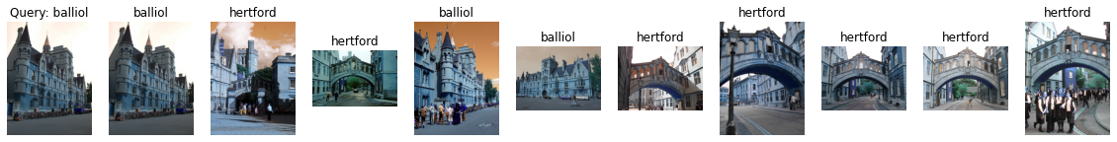

Label: balliol

Average Precision for query 13: 0.2616952925967066

Precision@k for query 13: 0.3

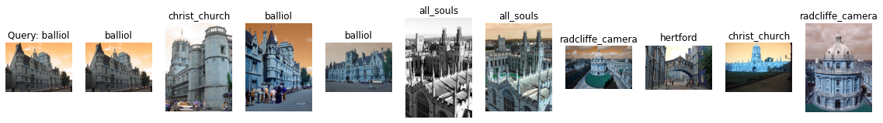

Label: balliol

Average Precision for query 14: 0.259879304989367

Precision@k for query 14: 0.3

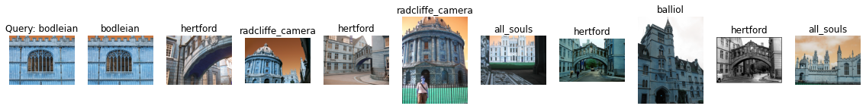

Label: bodleian

Average Precision for query 15: 0.15233166904490172

Precision@k for query 15: 0.1

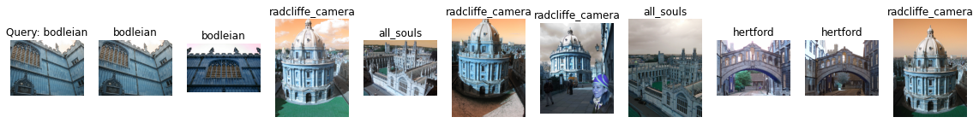

Label: bodleian

Average Precision for query 16: 0.11739838929638485

Precision@k for query 16: 0.2

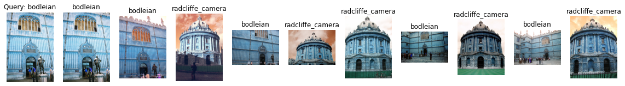

Label: bodleian

Average Precision for query 17: 0.26119537761225575

Precision@k for query 17: 0.5



Label: bodleian

Average Precision for query 18: 0.15829115803608415

Precision@k for query 18: 0.3

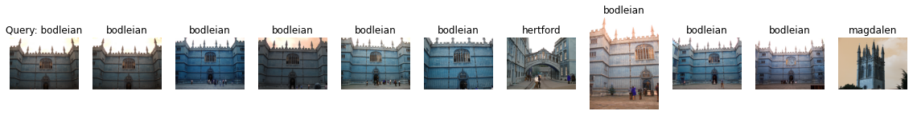

Label: bodleian

Average Precision for query 19: 0.4377036404375567

Precision@k for query 19: 0.8



Label: christ_church

Average Precision for query 20: 0.43116283414857126

Precision@k for query 20: 1.0



Label: christ_church

Average Precision for query 21: 0.6311108084472148

Precision@k for query 21: 1.0

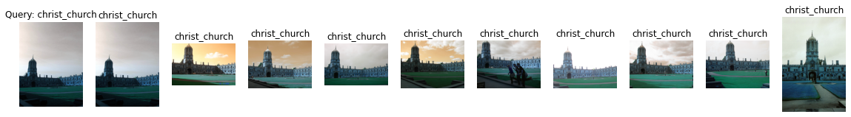

Label: christ_church

Average Precision for query 22: 0.4897148385338412

Precision@k for query 22: 1.0

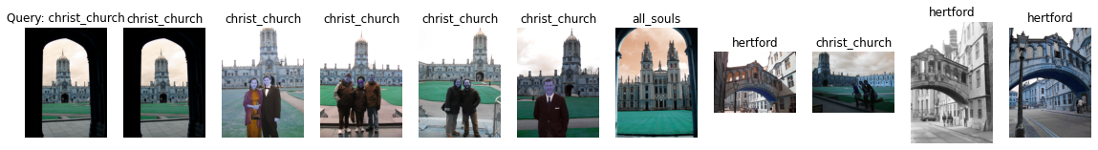

Label: christ_church

Average Precision for query 23: 0.3317404996718826

Precision@k for query 23: 0.6

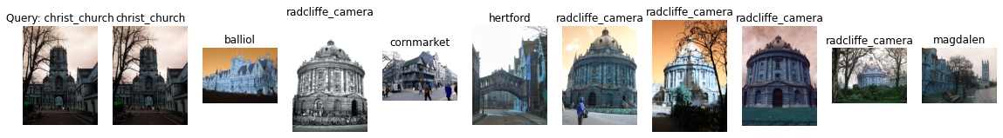

Label: christ_church

Average Precision for query 24: 0.11041446445058853

Precision@k for query 24: 0.1

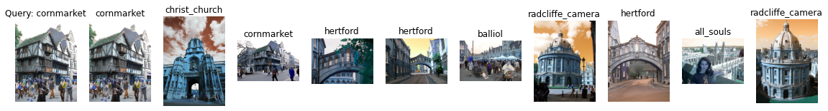

Label: cornmarket

Average Precision for query 25: 0.22850096430314323

Precision@k for query 25: 0.2

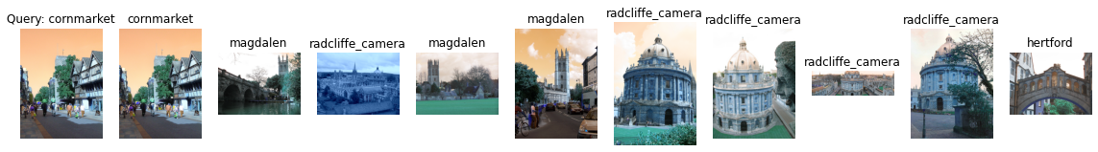

Label: cornmarket

Average Precision for query 26: 0.13446012779427002

Precision@k for query 26: 0.1

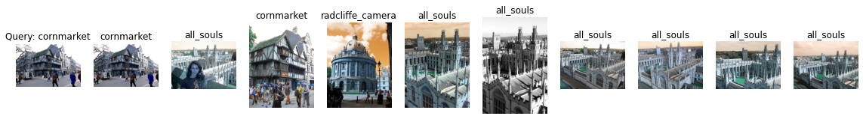

Label: cornmarket

Average Precision for query 27: 0.22888306436710085

Precision@k for query 27: 0.2

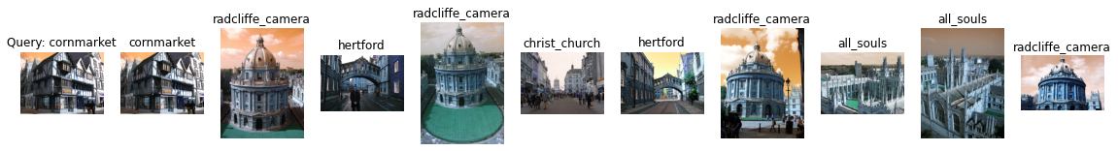

Label: cornmarket

Average Precision for query 28: 0.17459015444830409

Precision@k for query 28: 0.1

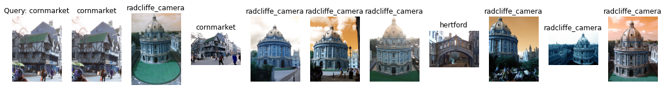

Label: cornmarket

Average Precision for query 29: 0.23167923594512946

Precision@k for query 29: 0.2

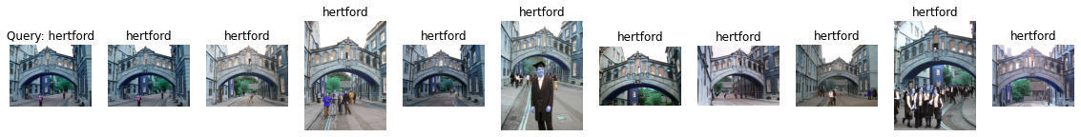

Label: hertford

Average Precision for query 30: 0.6660994316412044

Precision@k for query 30: 1.0

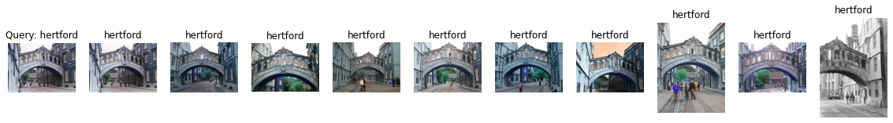

Label: hertford

Average Precision for query 31: 0.6478907968332456

Precision@k for query 31: 1.0

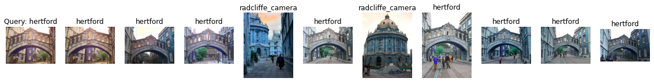

Label: hertford

Average Precision for query 32: 0.4495184008852982

Precision@k for query 32: 0.8



Label: hertford

Average Precision for query 33: 0.34149277716850224

Precision@k for query 33: 0.5

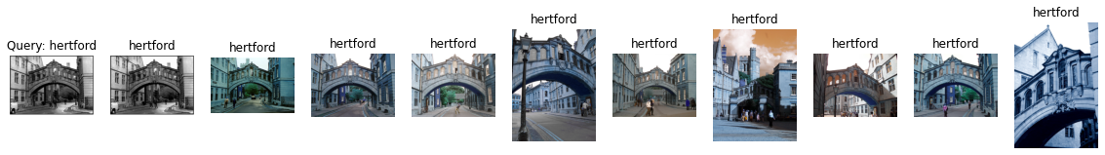

Label: hertford

Average Precision for query 34: 0.6903454686733371

Precision@k for query 34: 1.0

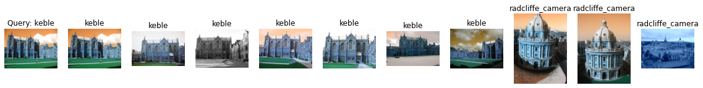

Label: keble

Average Precision for query 35: 1.0

Precision@k for query 35: 0.7

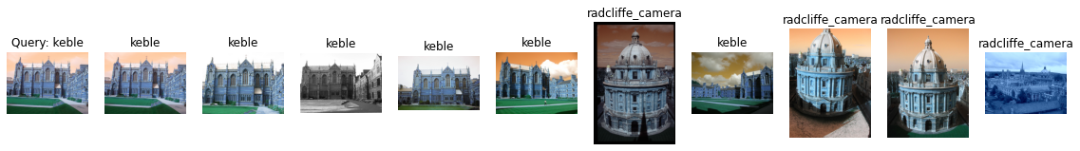

Label: keble

Average Precision for query 36: 0.9276437847866419

Precision@k for query 36: 0.6

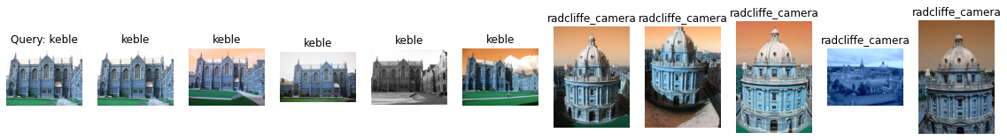

Label: keble

Average Precision for query 37: 0.8571428571428571

Precision@k for query 37: 0.5

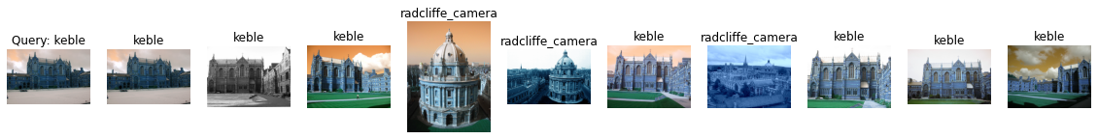

Label: keble

Average Precision for query 38: 0.8083333333333333

Precision@k for query 38: 0.7

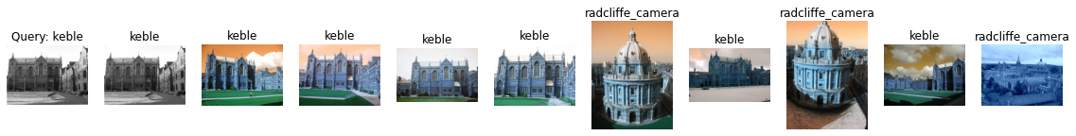

Label: keble

Average Precision for query 39: 0.9478458049886621

Precision@k for query 39: 0.7

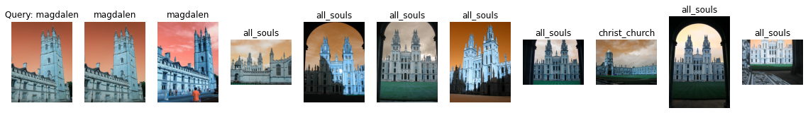

Label: magdalen

Average Precision for query 40: 0.09552093708466183

Precision@k for query 40: 0.2



Label: magdalen

Average Precision for query 41: 0.25224662147008287

Precision@k for query 41: 0.4



Label: magdalen

Average Precision for query 42: 0.09579569261370169

Precision@k for query 42: 0.2

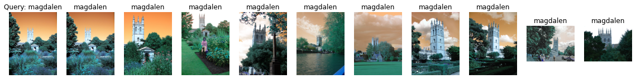

Label: magdalen

Average Precision for query 43: 0.5935664778742683

Precision@k for query 43: 1.0

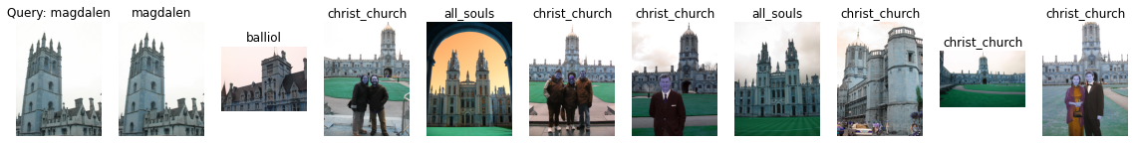

Label: magdalen

Average Precision for query 44: 0.09495796874165997

Precision@k for query 44: 0.1

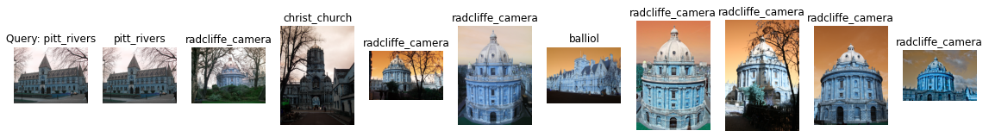

Label: pitt_rivers

Average Precision for query 45: 0.1843392530174722

Precision@k for query 45: 0.1



Label: pitt_rivers

Average Precision for query 46: 0.3463134983636123

Precision@k for query 46: 0.2



Label: pitt_rivers

Average Precision for query 47: 0.17699558000946236

Precision@k for query 47: 0.1

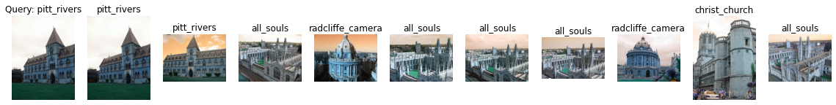

Label: pitt_rivers

Average Precision for query 48: 0.34300445328361717

Precision@k for query 48: 0.2



Label: pitt_rivers

Average Precision for query 49: 0.39612133371647457

Precision@k for query 49: 0.3

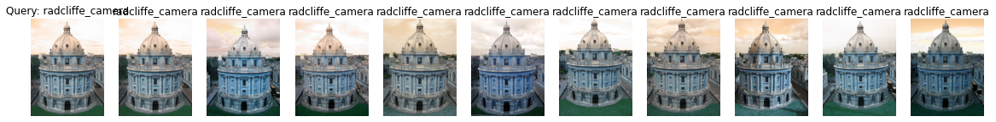

Label: radcliffe_camera

Average Precision for query 50: 0.6137797436662344

Precision@k for query 50: 1.0

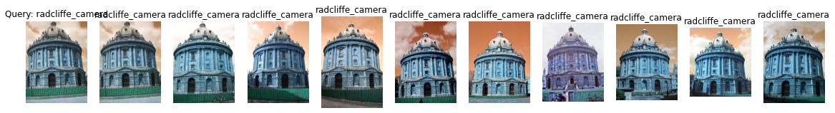

Label: radcliffe_camera

Average Precision for query 51: 0.7237409283911835

Precision@k for query 51: 1.0

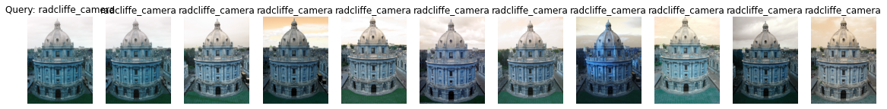

Label: radcliffe_camera

Average Precision for query 52: 0.6987974616218395

Precision@k for query 52: 1.0

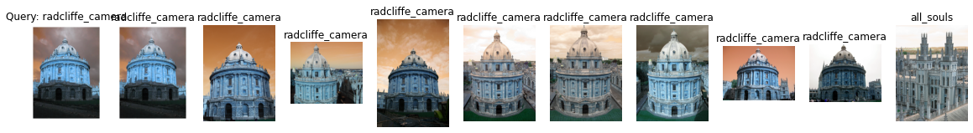

Label: radcliffe_camera

Average Precision for query 53: 0.6141923426304295

Precision@k for query 53: 0.9

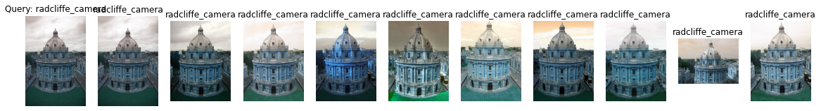

Label: radcliffe_camera

Average Precision for query 54: 0.6639061816773851

Precision@k for query 54: 1.0

k = 10

mAP = 0.38793251852104216